THE VALUES BULL’S EYE
Description
The dart board is divided into four areas of living that are important in life: work/education, leisure, relationships, and personal growth/health. In this exercise, you will be asked to look more closely at your personal values in each of these areas. Then, you will evaluate how close you are to living your life in keeping with your values. You will also take a closer look at the barriers or obstacles in your life that stand between you and your values and what you want to do to address each obstacle.
1. Work/Education refers to your career aims, your values about improving your education and knowledge, and generally feeling of use to those close to you or to your community (i.e., volunteering, overseeing your household).
2. Leisure refers to how you play in your life, how you enjoy yourself, your hobbies, or other activities that you spend your free time doing (i.e., gardening, sewing, coaching, fishing, playing sports).
3. Relationships refers to intimacy in your life, relationships with your children, your family of origin, your friends, and social contacts in the community.
4. Personal growth/health refers to your spiritual life, either in organised religion or personal expressions of spirituality as well as exercise, nutrition, and addressing health risk factors like drinking, drug use, smoking, weight.

Part 1. Identify Your Values
Start by describing your values within each of the four values areas. Your value should not be a specific goal but instead reflect the kind of person you would like to be over time. For example, you might want to get a degree, but what is your educational value? It might be to be a learner, to achieve a sense of mastery, to prepare yourself to serve the world or to take care of people you love. The degree is the goal; learning, mastery, serving, and caring are the values. Please write what you value – the qualities of the person you want to be - in each of the areas below.
Work/education:

Relationships:

Leisure:

Personal growth/health:

Part 2. Assess Your Current Progress on Values
Look at the values you have written above. Make an X on the dartboard in each area that best represents where you stand today. An X in the center means that you are living completely in keeping with your value for that area. An X far from bull’s eye means that your life is way off the mark in an area.

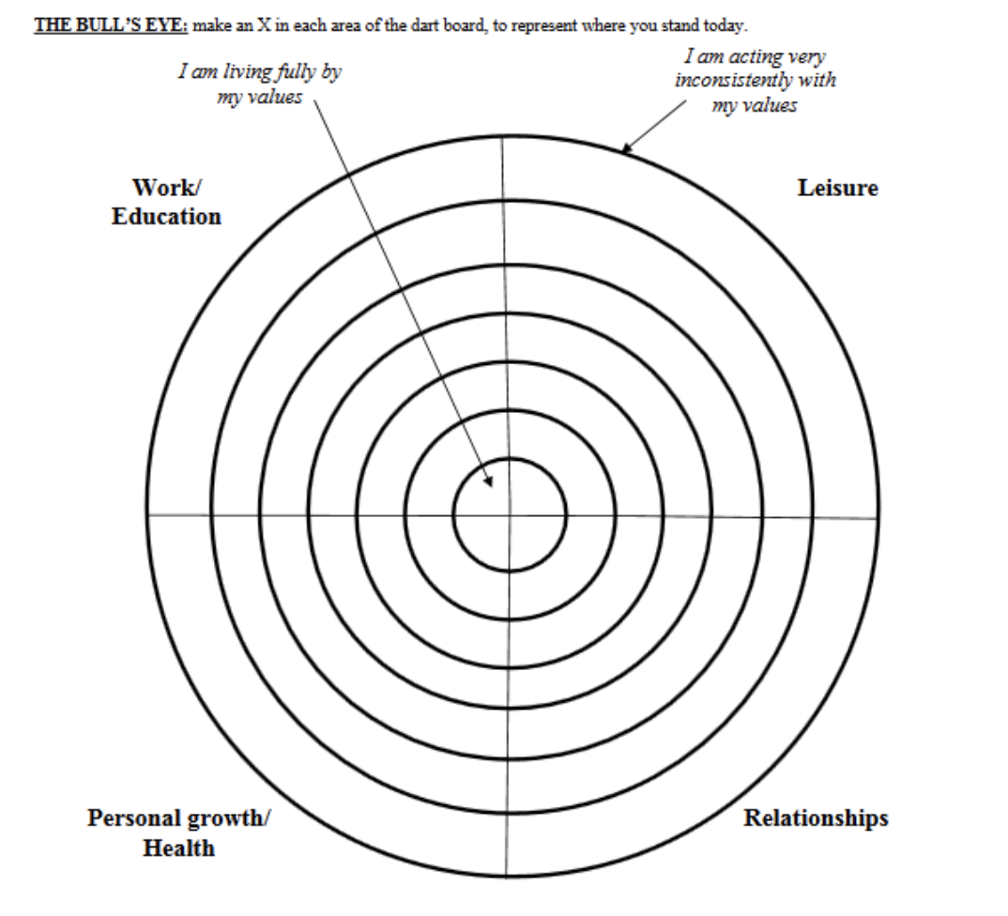
Part 3. Identify Your Obstacles
Write down what stands between you and your values. What gets in the way of you being the person you want to be? Describe any obstacles below.
Obstacle 1:

Obstacle 2:

Obstacle 3:

Obstacle 4:

Estimate to what extent the obstacle (s) you just described stop you from living according to your values. Circle one number between 1 and 7 below that best describes how powerful each obstacle is.
1 = Doesn’t prevent me at all: 7 = Completely prevents me
Obstacle 1: 1 2 3 4 5 6 7
Obstacle 2: 1 2 3 4 5 6 7
Obstacle 3: 1 2 3 4 5 6 7
Obstacle 4: 1 2 3 4 5 6 7

Part 4. My Valued Action Plan
Think about actions you can take in your daily life that would tell you that you are zeroing in on the bull’s-eye in each important area of your life. These actions could be small steps toward a particular goal, or they might be bigger actions that reflect who you want to be. Usually, taking a valued step includes being willing to encounter the obstacle(s) you identified and to take the action anyway. Try to identify at least one value-based action you are willing to take in each of the four areas listed below.

Work/education:

Relationships:

Leisure:

Personal growth/health:

Leisure: Personal growth

- Based on the work of Tobia Lundgren and colleagues. Lundgren, T., Luoma, J. B., Dahl, J., Strosahl,K., & Melin, L. (2012). The bull's-eye values survey: A psychometric evaluation. Cognitive and Behavioral Practice, 19, 518-526 26.10.1016/j.cbpra.2012.01.004 [Crossref] [Web of Science ®], [Google Scholar]

